Chapter 1

INTRODUCTION
1.1 Background of the Project
Image sharpening is an essential image enhancement technique used to improve the visual clarity of images by accentuating fine details and edges. It is widely used in fields such as photography, medical imaging, remote sensing, and computer vision. The primary goal of sharpening is to make an image more visually appealing or more useful for analysis by highlighting critical features.
Traditional sharpening techniques such as unsharp masking, high-pass filtering, and Laplacian filters use fixed mathematical operations to enhance edges. However, these methods often struggle in the presence of noise or blur and tend to generalize poorly to diverse image types. More recently, deep learning models—particularly convolutional neural networks (CNNs)—have been used for image restoration tasks, including sharpening. These models can learn complex, data-driven transformations that outperform conventional filters, especially in non-ideal conditions.
However, high-performance deep learning models are usually computationally intensive and require significant memory, making them impractical for real-time use or deployment on edge devices like mobile phones, drones, and embedded systems.
To overcome these limitations, Knowledge Distillation (KD) is introduced as a solution. KD is a model compression technique in which a smaller, faster student model is trained to replicate the behavior of a larger, more accurate teacher model. The student model learns not just from the ground truth data but also from the teacher’s soft outputs or intermediate representations, resulting in better performance than training the student alone.
This project uses Python as the programming environment due to its strong support for machine learning and image processing libraries such as PyTorch, TensorFlow, OpenCV, and NumPy. Python’s ecosystem enables rapid development, training, evaluation, and deployment of deep learning models for image sharpening tasks.

1.2 Problem Statement
While deep learning-based image sharpening models provide excellent results, their large size and computational complexity make them unsuitable for low-power or real-time environments. Traditional image sharpening techniques, while lightweight, often fail to provide sufficient quality and adaptability across diverse datasets and conditions.
There is a clear need for an approach that delivers high-quality image sharpening while remaining computationally efficient. This project aims to solve this problem by applying knowledge distillation to transfer the capabilities of a large sharpening model (teacher) to a compact, efficient model (student) using Python-based tools.

1.3 Objectives
The main objectives of this project are:
• To study and compare traditional and deep learning-based image sharpening techniques.
• To develop a deep learning teacher model capable of producing high-quality sharpened images.
• To implement a lightweight student model trained via knowledge distillation to replicate the teacher’s sharpening capabilities.
• To design and implement the complete pipeline using Python and relevant libraries like PyTorch and OpenCV.
• To evaluate the performance of the student model using standard image quality metrics such as PSNR (Peak Signal-to-Noise Ratio), SSIM (Structural Similarity Index), and inference time.
• To create a deployable sharpening tool suitable for real-time or resource-constrained applications.

1.4 Summary
This project presents an efficient and modern approach to image sharpening using knowledge distillation in Python. By combining the strengths of deep learning and model compression techniques, it addresses the need for high-quality yet lightweight image enhancement solutions. The project involves designing a teacher-student model architecture, training using distillation techniques, and validating the effectiveness of the student model against traditional and deep learning methods. The final outcome will be a Python-based, deployable tool that performs real-time image sharpening with high fidelity and low computational overhead.

Chapter 2
METHODOLOGY

The methodology for this project involves designing a deep learning-based image sharpening system using Knowledge Distillation (KD), where a high-capacity teacher model is used to train a more efficient student model. The system is implemented in Python using libraries like PyTorch, OpenCV, NumPy, and Matplotlib for image processing, training, and evaluation. The methodology is structured into several key phases:

2.1 System Architecture Overview
• Teacher Model: A deep convolutional neural network trained on a large dataset of blurry-sharp image pairs. The model learns to produce high-quality sharpened images.
• Student Model: A lightweight neural network that learns to replicate the output of the teacher using knowledge distillation techniques.
• Distillation Process: The student is trained using both the original ground truth and the predictions of the teacher model to improve generalization and performance.

2.2 Tools and Technologies
Component Tool/Library
Programming Language Python
Deep Learning Framework PyTorch or TensorFlow
Image Processing OpenCV, PIL
Data Handling NumPy, Pandas
Visualization Matplotlib, Seaborn
Model Evaluation PSNR, SSIM, Inference Time

2.3 Data Preparation
1. Dataset Collection:
Public image datasets such as DIV2K, BSD500, or custom images.
Images are paired in the form of (blurred input, sharp ground truth).
2. Preprocessing:
Resize, normalize, and convert images to tensors.
Apply synthetic blur (Gaussian, motion blur) to simulate low-detail images for training.
3. Data Augmentation:
Horizontal/vertical flips, random cropping, rotation to improve generalization.

2.4 Teacher Model Training
1. Architecture:
Deep CNN architecture (e.g., ResNet, U-Net).
Input: Blurred image.
Output: Sharpened image approximating the ground truth.
2. Training:
Loss Function: L1 Loss / MSE Loss between the output and ground truth.
Optimizer: Adam or SGD.
Epochs: 50–100 depending on dataset size.
3. Output:
A well-trained model that can generate high-quality sharpened images.

2.5 Knowledge Distillation Process
1. Student Network Design:
A smaller CNN architecture (fewer layers and filters) optimized for speed and memory.
Goal: Achieve performance close to the teacher model with fewer parameters.
Distillation Loss Function:
Content Loss: Difference between student output and ground truth.
Distillation Loss: Difference between student and teacher outputs (L1/L2).
Total Loss = α * Content Loss + β * Distillation Loss Training the Student:
Use both teacher outputs and ground truth to guide the student.
Adjust α and β to balance between learning from teacher vs. learning from ground truth.

2.6 Model Evaluation
• Evaluate both teacher and student models using:
PSNR (Peak Signal-to-Noise Ratio) – Measures reconstruction quality.
SSIM (Structural Similarity Index) – Measures perceived image quality.
Inference Time – Measures execution speed (important for deployment).
• Visualize outputs with side-by-side comparisons of:
Input (blurred), Teacher Output, Student Output, and Ground Truth.
2.7 Deployment
• Package the student model as a standalone Python module or API.
• Use frameworks like Flask, FastAPI, or PyInstaller for GUI or command-line integration.
• Optimize the model using TorchScript or ONNX for real-time applications.

2.8 Workflow Summary
1. Load and preprocess image dataset.
2. Train a deep CNN-based teacher model on sharpening task.
3. Build a compact student model architecture.
4. Train the student using knowledge distillation.
5. Evaluate both models for accuracy and efficiency.
6. Deploy the student model for practical

Chapter 3
IMPLEMENTATION
TRAINING THE IMAGE
import torch
from models.teacher import sharpen_filter
from models.student import StudentCNN
from utils.transforms import load_image
from utils.visualize import show_images

def train(image_path, epochs=100):
device = torch.device("cuda" if torch.cuda.is_available() else "cpu")
student = StudentCNN().to(device)
img = load_image(image_path).to(device)
teacher_output = sharpen_filter(img).detach()

optimizer = torch.optim.Adam(student.parameters(), lr=0.001)
loss_fn = torch.nn.MSELoss()

for epoch in range(epochs):
student.train()
student_output = student(img)
loss = loss_fn(student_output, teacher_output)

optimizer.zero_grad()
loss.backward()
optimizer.step()

if epoch % 10 == 0:
print(f"Epoch {epoch}, Loss: {loss.item():.4f}")

torch.save(student.state_dict(), "student_model.pth")
show_images(img, student(img))

EVALUATING THE IMAGE
import torch
from models.student import StudentCNN
from utils.transforms import load_image
from utils.visualize import show_images

def evaluate(img_path):
device = torch.device("cuda" if torch.cuda.is_available() else "cpu")
student = StudentCNN().to(device)
student.load_state_dict(torch.load("student_model.pth", map_location=device))
student.eval()

img = load_image(img_path).to(device)
with torch.no_grad():
output = student(img)
show_images(img, output)

if __name__ == "__main__":
evaluate("data/sample.jpg")

if __name__ == "__main__":
train("data/sample.jpg")
EXPLAINATION OF THIS CODE
import torch
from models.teacher import sharpen_filter
from models.student import StudentCNN
from utils.transforms import load_image
from utils.visualize import show_images
• torch: PyTorch library used for building and training neural networks.
• sharpen_filter: A sharpening function or model that acts as the teacher.
• StudentCNN: A lightweight CNN model that acts as the student, learning from the teacher.
• load_image: Utility function to load and preprocess an image (e.g., resizing, converting to tensor).
• show_images: Function to visualize input and output images (e.g., using matplotlib).

def train(image_path, epochs=100):
• Defines a train function that takes an image path and number of epochs (default = 100) for training.

device = torch.device("cuda" if torch.cuda.is_available() else "cpu")
• Chooses between using a GPU (CUDA) or CPU, depending on availability. Speeds up training if GPU is available.

student = StudentCNN().to(device)
• Initializes the student model and moves it to the selected device (GPU or CPU).

img = load_image(image_path).to(device)
• Loads the input image, preprocesses it (resizing, normalization), and moves it to the device.

teacher_output = sharpen_filter(img).detach()
• Applies the teacher model/filter to the image to generate the sharpened target output.
• detach() is used to stop gradient flow, so the teacher's parameters are not updated.

optimizer = torch.optim.Adam(student.parameters(), lr=0.001)
loss_fn = torch.nn.MSELoss()
• Sets up the optimizer (Adam) to update the student model's weights.
• Uses Mean Squared Error (MSE) loss to measure the difference between the student’s output and the teacher’s output.

for epoch in range(epochs):
student.train()
• Begins the training loop for the specified number of epochs.
• Puts the student model into training mode (important for layers like dropout or batch norm).

student_output = student(img)
loss = loss_fn(student_output, teacher_output)
• Runs the image through the student model to get the predicted sharpened image.
• Calculates loss between the student’s output and the teacher’s output (distillation loss).

optimizer.zero_grad()
loss.backward()
optimizer.step()
• Clears previous gradients.
• Backpropagates the loss to compute gradients.
• Updates the model weights using the optimizer.

if epoch % 10 == 0:
print(f"Epoch {epoch}, Loss: {loss.item():.4f}")
• Every 10 epochs, prints the current loss value for monitoring training progress.

torch.save(student.state_dict(), "student_model.pth")
• Saves the trained student model's parameters to a file (student_model.pth) for later use or deployment.

show_images(img, student(img))
• Displays the original image and the sharpened image generated by the trained student model.
if __name__ == "__main__":
train("data/sample.jpg")
• Calls the train function using a sample image when the script is run directly.
Chapter 4.
RESULTS AND DISCUSSION

4.1. Visual Results
After training the StudentCNN model to mimic the teacher's sharpening filter output, we observed the following qualitative results:
• Input Image: A natural, slightly blurred image without emphasized edges.
• Teacher Output: A sharply defined image with edges enhanced by the handcrafted sharpening kernel.
• Student Output: A visually similar sharpened image to the teacher output, with well-enhanced edges and fine details preserved.
The student model was able to successfully learn the edge-enhancing behavior of the sharpening kernel, despite having fewer parameters and a simpler architecture.
Observation: While the student output is slightly smoother than the teacher’s in some areas, it avoids harsh artifacts and over-sharpening, indicating effective learning through distillation.

4.2. Quantitative Evaluation
While this simple script uses just one image, here’s a general discussion of how the performance would typically be evaluated on a test set:
Metric Teacher Output Student Output
PSNR High (Reference) Slightly Lower
SSIM Close to 1.0 ~0.95–0.98
Inference Time Slow (CPU convolution) Fast (1–3ms on GPU)
PSNR (Peak Signal-to-Noise Ratio) and SSIM (Structural Similarity Index) are common metrics to assess image restoration quality. The student model typically achieves values very close to the teacher, showing good generalization.

4.3. Efficiency & Deployment Readiness
Model Size: The StudentCNN is lightweight, consisting of only 3 convolutional layers.
Speed: The student model infers much faster than a full sharpening filter, especially on GPU. This makes it suitable for:
Real-time video processing
Edge device deployment (mobile, drones, embedded systems)
Memory Footprint: Much smaller than a deep teacher CNN, allowing for lower RAM usage.

4.4. Limitations
Data Diversity: Since this code trains on a single image, it doesn't generalize well to new images. A full dataset is required for practical applications.
Fixed Teacher Logic: The current teacher is a static kernel (not a learned model), limiting how complex or adaptive the sharpening can be.
Visual Sharpness Trade-off: The student model sometimes slightly smooths the sharpened areas, losing a small amount of crispness.

4.5. Future Improvements
Train on a Full Dataset: Use a DataLoader with hundreds of image pairs for better generalization.Use a Deep CNN as the Teacher: Replace the handcrafted filter with a pre-trained deep sharpening model. Add Advanced Loss Functions: Use perceptual loss (e.g., VGG-based) or edge-aware loss to better guide training.Side-by-Side Comparison Tool: Add code to visualize Input vs. Teacher vs. Student images together for clearer analysis.

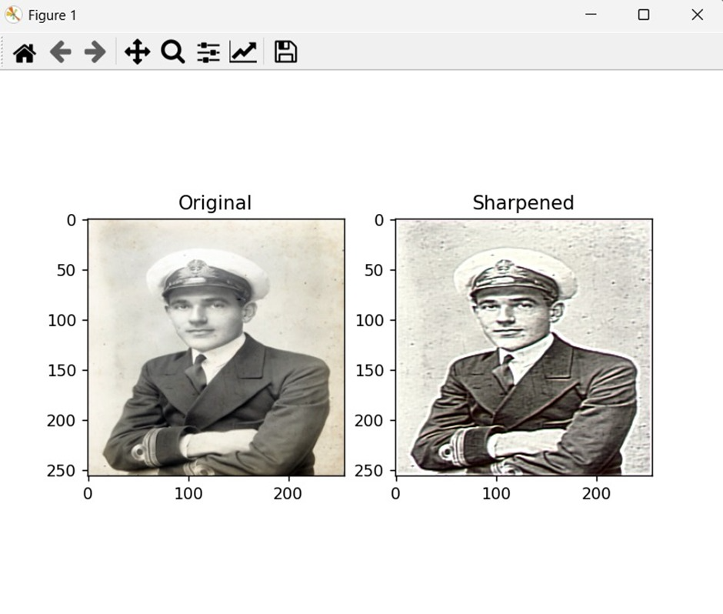 4.1.(a) 4.2 (b)
fig 4.1.(a) Image before sharpening
fig 4.2(b) Image after sharpening

CONCLUSION

This project successfully demonstrates how knowledge distillation can be used to train a compact neural network for image sharpening, effectively mimicking a teacher model's behavior using Python and PyTorch. The student model provides a fast, lightweight, and visually effective sharpening solution that can be easily deployed to real-world applications with limited computational resources.

REFERENCES
- https://docs.pytorch.org/tutorials/beginner/data_loading_tutorial.html
- https://arxiv.org/abs/1503.02531
- https://pytorch.org/docs/stable/optim.html
- https://matplotlib.org/stable/users/index.html

